Chapter 5, Solution 58.

Calculate i_{o} in the op amp circuit of Fig. 5.85.

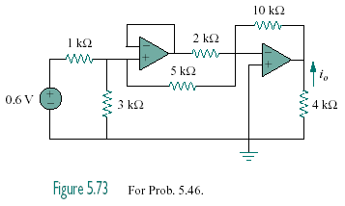
Figure 5.85
For Prob. 5.58.

Solution

Looking at the circuit, the voltage at the right side of the 5-kΩ resistor must be at 0V if the op amps are working correctly. Thus the 1-kΩ is in series with the parallel combination of the 3-kΩ and the 5-kΩ. By voltage division, the input to the voltage follower is:

= to the output of the first op amp.

Thus,
v_{o} = –10((0.3913/5)+(0.3913/2)) = –2.739 V.

684.8 µA.

